Process to clear blocked Method Context

Entries in the Method Context table on the Server Status page may lead to performance degradation. To restore system stability, these entries should be cleared.
Navigate to Site -> Utilities -> Server Status:
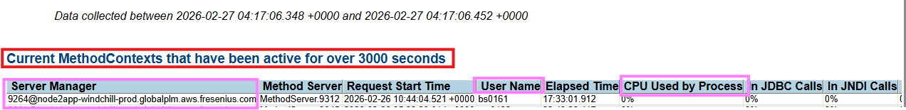

Step 1: Please connect with User and understand the actions considering below scenario:
- If user confirms that he/she has some activity running and activity can be completed in a while, we can wait and monitor the status.
- If user confirms that he doesn’t need to run it anymore and can cancel, advise clearing the cache and closing browser sessions before logging off.
- If user is unreachable/offline/OOO.
- User confirms that no process is running and blockage can be clear.
Considering Scenario 1 & 2, if blockage is still not clear then all 4 scenarios, next steps can be followed.

Step 2: Please collect the details such as username, connected node, MethodServer Process and running time.

Step 3: Follow the process to connect to Server machine:
- Login into AWS portal with your credentials
AWS URL: Accounts | AWS access portal

- Expand GPDM-WINDCHILL-Prod --> Click on Access keys
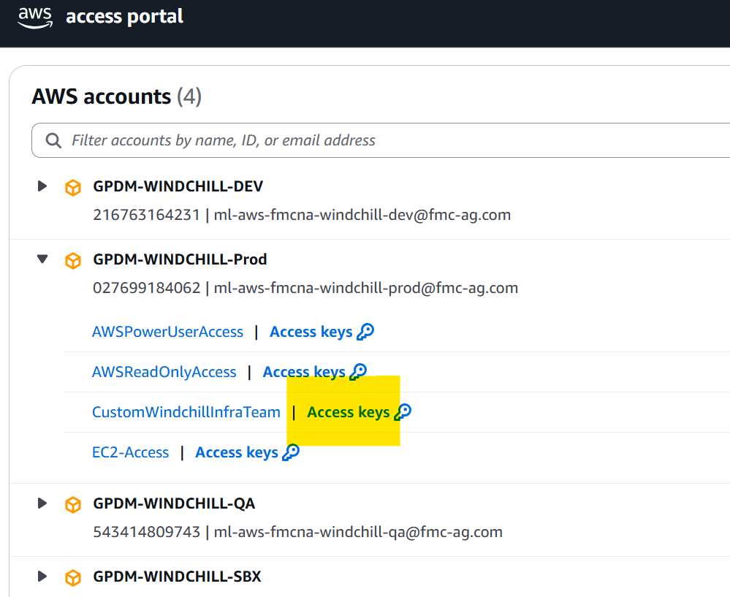
New tab opens. From PowerShell Tab, Copy the AWS environment variables.
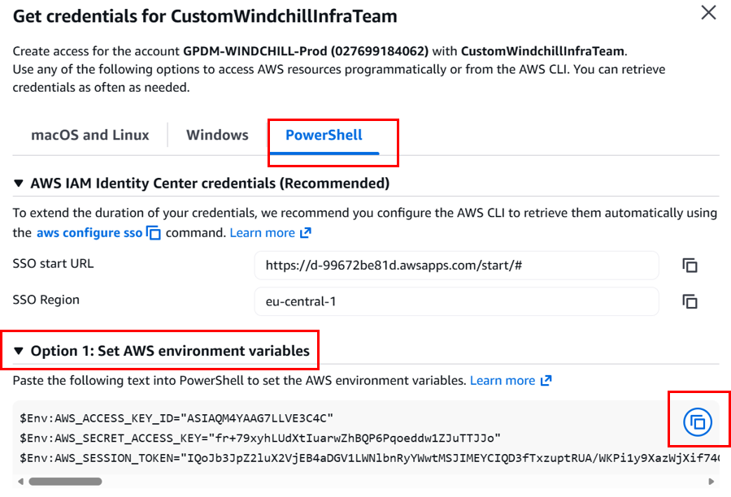

- Launch PowerShell in VDI and paste the AWS environment variables.
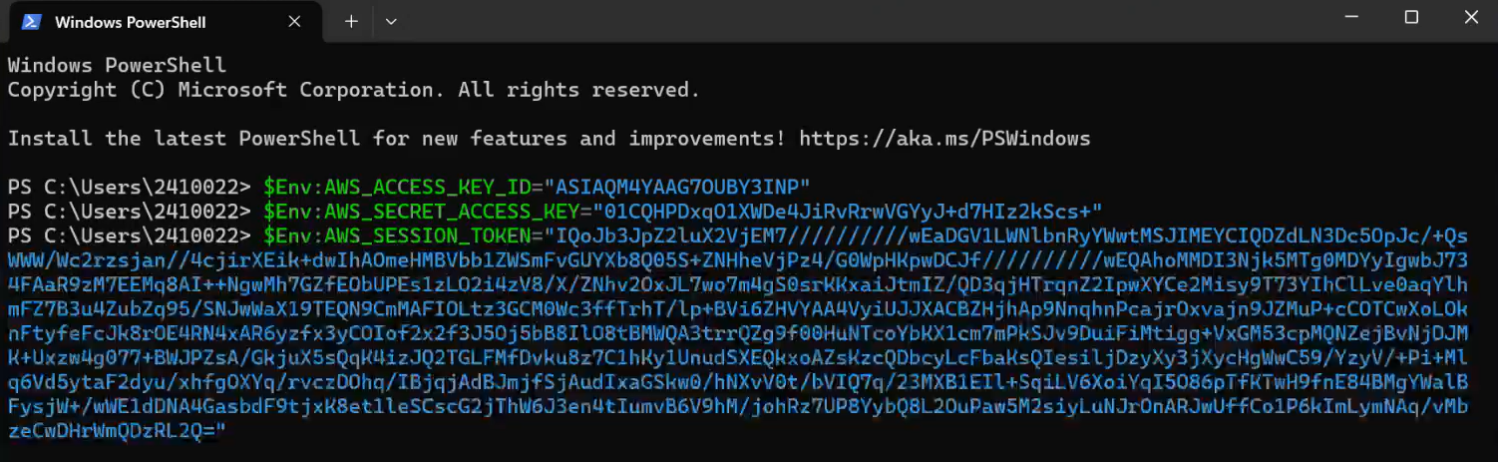

- Configure Region in the PowerShell. This is one time configuration.Run ‘aws configure’ command
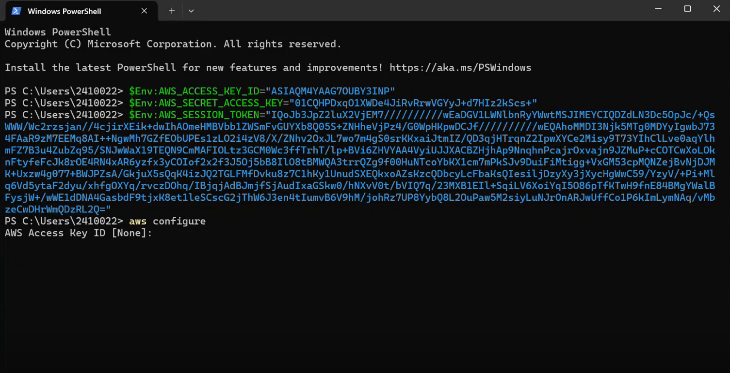
Below are the required values to be entered for ‘Aws Configure’:
AWS Access Key ID [None]: Enter {Don't type any value just do enter}
AWS Secret Access Key [None]: Enter {Don't type any value just do enter}
Default region name [Noe]: Type eu-central-1
Default output format [None]: Enter {Don't type any value just do enter}
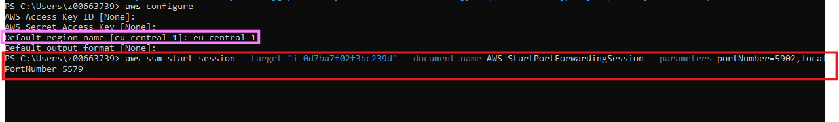

- Enter below command to launch open session with Server Machine.
aws ssm start-session --target "i-0d7ba7f02f3bc239d" --document-name AWS-StartPortForwardingSession --parameters portNumber=5902,localPortNumber=5579
With Target, we need to provide the instance id for the Node which needs to connect. For Windchill-Node2-APP-PROD, Instance ID is i-0d7ba7f02f3bc239d
{ login into AWS --> Expand GPDM-WINDCHILL-Prod --> click on CustomWindchillInfraTeam --> Search --> Search for Session Manager --> Start session --> Respective Instance ID for each node individually we can copy}

- Launch VNC Viewer, Type localhost:5579 and click on connect.
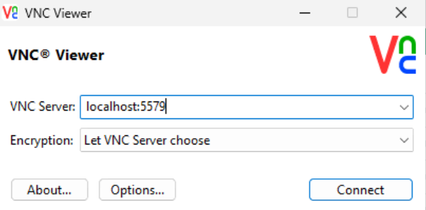
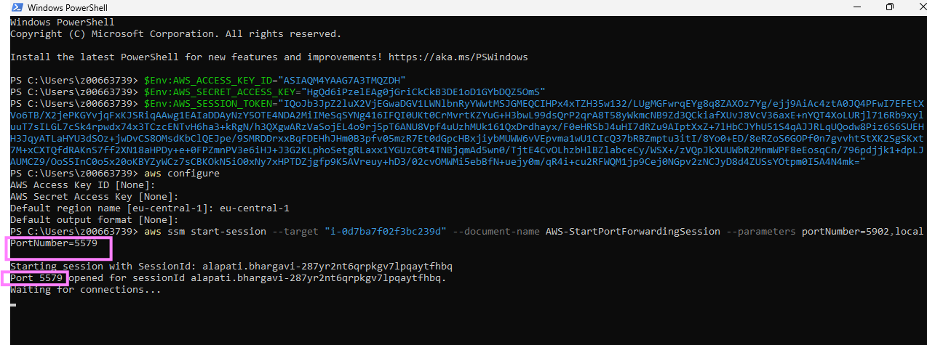
- Click on continue
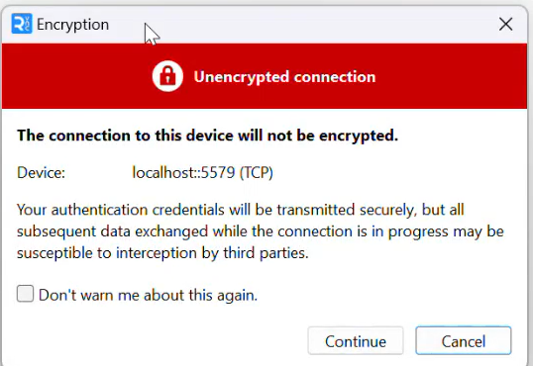
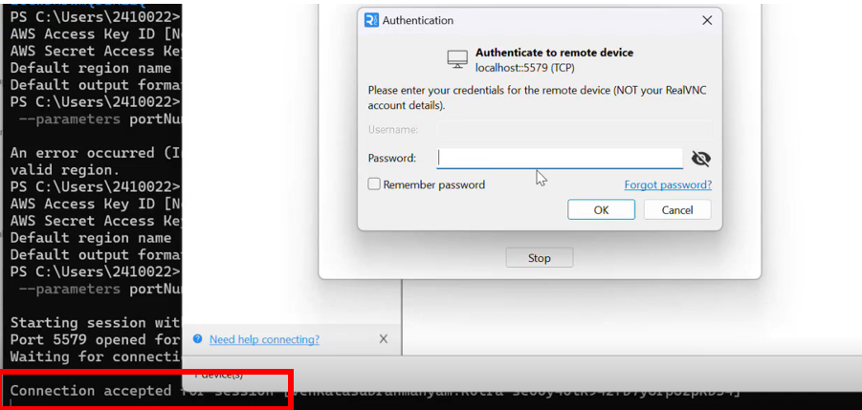
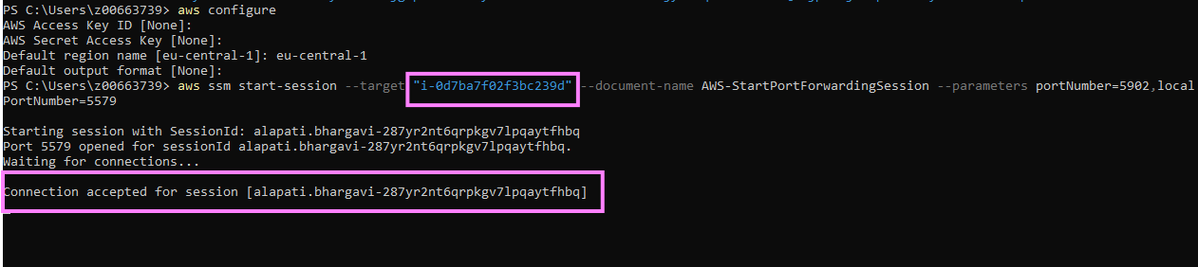
- Password can be retrieved from Secret Managers:
AWS Console > login into AWS > Expand GPDM-WINDCHILL-Prod > click on CustomWindchillInfraTeam > New Tab opens > Search for Secrets Manager > click on Secrets Manager > click on Windchill-Application-Nodes > Click on Retrieve Secret value > User the password in VNC VIEWER > Click on OK
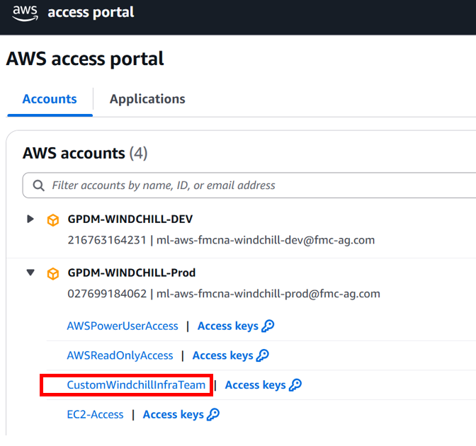
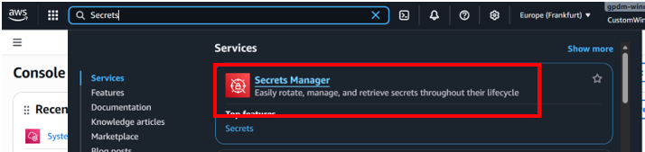
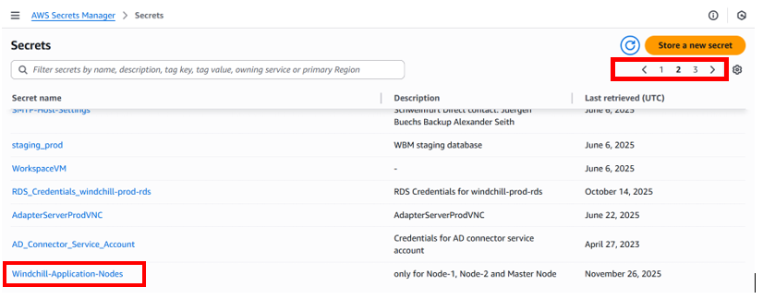
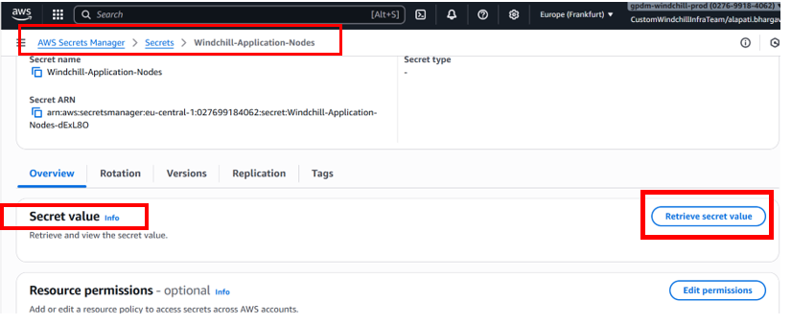
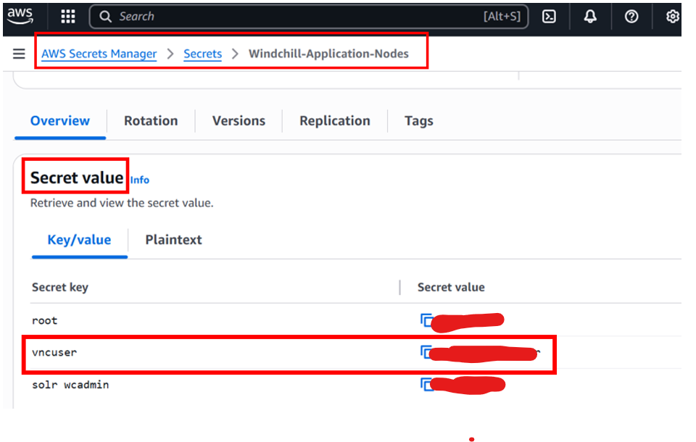
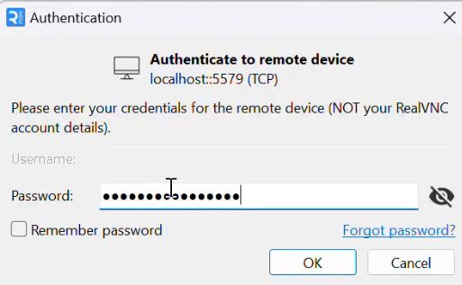

Step 4: Process to connect to SMJ and clear the blockages:
- Launch Terminal in Server Machine, type smj and enter.
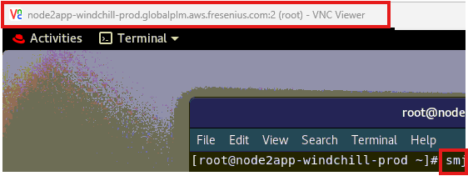
- Click on Insecure Connection.
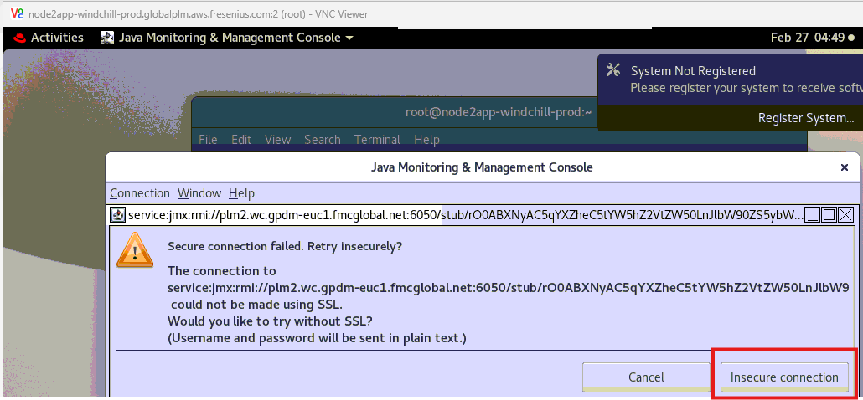

- In Windchill Tab, we can see all the running processes.
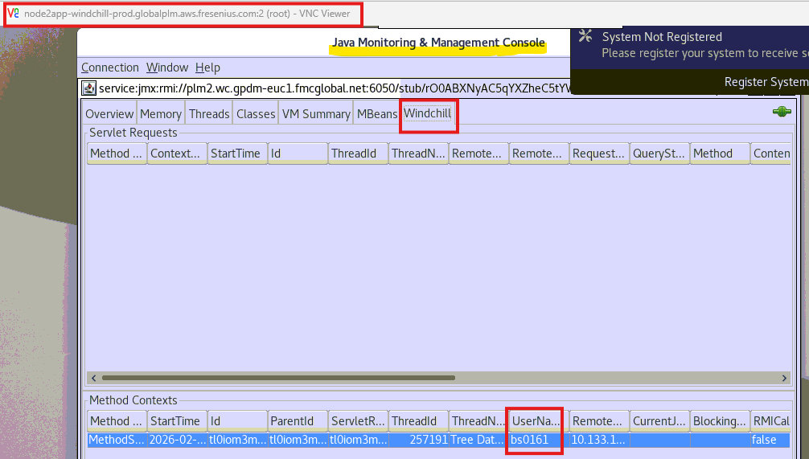

- Locate the Blocked entry and Inturrupt.
Select the entry -> Right Click -> click on Interrupt -> click OK in Confirm Interrupt popup
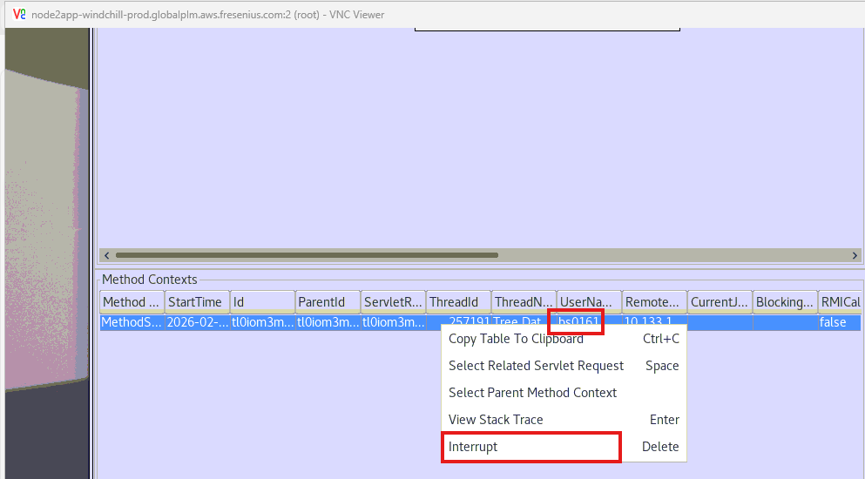
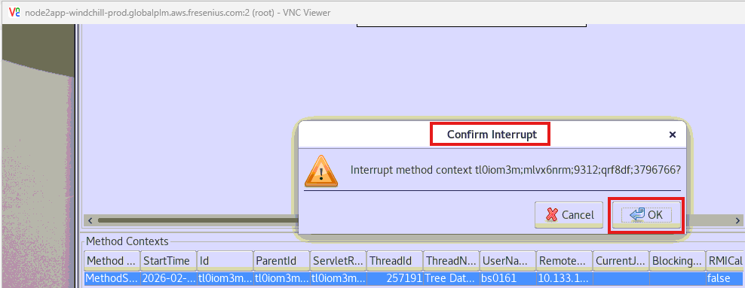

- Validate if Interrupted process is removed from the table. Close the VNC Viewer and exit from PowerShell press ‘Ctrl+C’.

- Validate Server Status page if Method context is clear or not.

Step 4: Restarted Particular Method Server Process.
- If Method Context is not clear from Jconsole and Server Status page, we need to restart the Particular MethodServer Process.
- To restarted MethodServer Process, pl create an Admin Activity and seek approval from Ravi (EST) or Olivier de Bruijn /Natalie Stanyon(CET).
Please note that If there is no response from Approvers (say within 1 hr), proceed with restart seeking approval post event.

Note: Try avoiding restart as much possible, leveraging this link that is still valid (GPDM_Windchill_PROD_JCONSOLE_Connect - Knowledge Base Global PLM Toolchain (Admin) - blue.space) for targeted killing of a java thread associated to transaction that is causing instability- high memory usage/CPU/etc.

